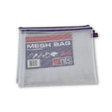
Stationery List 2023 – 2024
Mesh Homework Folders with zip ->
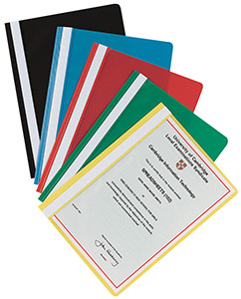
Scoil Bhríde, Ballydehob
Project Folders ->
Junior Infants
Pencils
Eraser
Topper
Colours – Twistables
No Gel Pens
4 x project folders- see picture
3 x A5 button folders
1x glue (e.g Pritt Stick)
1x scissors
1x A4 Mesh Homework Folder with zip – see picture

5 x project folders- see picture

1st Class
Pencils
Eraser
Topper
Colours – Twistables
No Gel Pens
2 x A4 Button Folder
5 x project folders- see picture
1x glue (e.g Pritt Stick)
1x scissors
1x A4 Mesh Homework Folder with zip – see picture

Senior Infants
Pencils
Eraser
Topper
Colours – Twistables
No Gel Pens
4 x project folders- see picture
3 x A5 button folders
1x glue (e.g Pritt Stick)
1x scissors
1x A4 Mesh Homework Folder with zip – see picture

2nd Class
Pencils
30 cm ruler
Eraser
Topper
Red biro
2 x A4 Button Folder
4 x project folders- see picture
Colours – Twistables, Colouring Pencils/Crayons.
1x glue (e.g Pritt Stick)
1x scissors
1x A4 Mesh Homework Folder with zip – see picture

Scoil Bhríde, Ballydehob
4th , 5th Class and 6th Class
30cm Ruler
Red, Blue, Black Pens
Pencil, Topper, Eraser
Set of Colours
5 x project folders- see picture
1 x Glue (e.g Pritt Stick)
1 x Scissors
Note: No Compass or Protractor needed
1x A4 Mesh Homework Folder with zip – see picture

3rd Class
5 x project folders- see picture
Pencils, Eraser, Topper, Red and Blue Pen
30 cm ruler
2 x A4 Button Folder
5 x project folders- see picture
Colours – Twistables, Colouring Pencils/Crayons.
1x glue(e.g Pritt Stick)
1x scissors
1x A4 Mesh Homework Folder with zip – see picture

